Specialised Cells Summary Sheet

Name | Plant/Animal | Function | Features | Diagram
Muscle | Animal
Nerve
Blood |  |  | RBC has large surface area
Fat
Guard
Xylem |  | To transport water from roots to leaves
Phloem
Root |  |  |  | 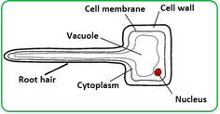
Leaf (palisade)

